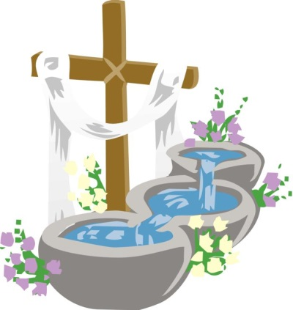
Dear parents and or Guardians
The Roman Catholic Church and the Archdiocese of Baltimore have the following requirements for your child to receive the sacrament of baptism.
Through Baptism, God enables us to participate in his life in Jesus Christ and makes us his children. It is through this sacrament that we receive the Holy Spirit and become members of the People of God, of the Body of Christ, which is the Church. Baptism becomes our commitment to grow in this new life and to strive to acquire spiritual maturity. By baptism, God purifies us from sin.
Baptism is the sacrament of faith which has the Risen Christ as its source, and it is the offer of salvation for all people. Intimately linked to Confirmation and to Eucharist, Baptism is, with these two sacraments, Christian Initiation. The child is baptized in the faith of his/her parents, or his/her godparents and of the Church.
Since Vatican II has directed Catholics to celebrate the Sacraments and Liturgy with “full, active and conscious” participation, we ask that parents/guardians participate first in an initial meeting with Pastor or Coordinator of Religious Education and then with godparents participate in two 2-hour Baptism Preparation Sessions to update their understanding of baptism, embrace the important responsibilities of Christian parenting.
In order that a child be baptized, it is necessary that…
- the parents consent, or at least one of them, or someone legally standing in their place,
- and that there is reasonable hope that the child will be brought up in the Catholic Faith.
GODPARENTS: A person may only have one or two godparents (also called sponsors); if two are chosen, they must be male and female.
In order for someone to be eligible as a godparent, these are requirements…
- they be chosen by the parents,
- have the ability and the intention to fulfill the role,
- be at least 16 years of age, and…
- be a confirmed Roman Catholic, who has already received the Most Holy Eucharist, is leading a life in harmony with the Catholic Faith (including Marriage) and will be a good role model for the one being baptized,
- and be neither the father nor the mother of the child.
- A baptized person who belongs to another Christian community may be admitted only as a “Christian witness” (not a godparent) provided that there is at least one Roman Catholic godparent who fulfills the above criteria. A non-baptized person cannot be a witness.

C. Baptismal Preparation at Transfiguration
In order to respect your request for the baptism of your child, you are invited to follow closely the stages of preparation offered below...
- Contact your parish office and express your desire to have your child baptized.
- Introduce yourself to the parish priest if you do not already know him personally.
- Open yourself to the invitation to actively join the faith community of your parish. If you are not registered parishioners, please consider becoming involved in the prayer and celebration of the Sunday Eucharistic community.
- You will be invited to participate in some manner of faith formation prior to the baptism of your child. This may take the form of a meeting(s) with the Pastor, Coordinator of Religious Education and participation in two 2-hour baptismal preparation session for parents/guardians and godparents
It is extremely important to take your faith-life seriously because, before God, you have taken on an awesome responsibility for the salvation of another—your own child! Your commitment and openness to baptismal preparation will help develop the faith-life of your child as he/she matures.

Date Schedule for Sacrament of Baptism:

Priest or Deacon Celebrating the Sacrament:
